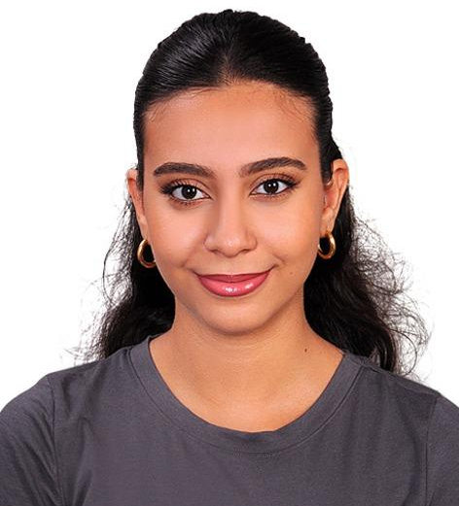  Due to my strong interest in filmmaking and cinema, particularly Turkish cinema, I moved to Istanbul to pursue this field at the university level. I am a Radio, Television, and Cinema student at Istanbul Aydın University, with hands-on experience in film production, photography and videography. Background in acting and voice-over, supported by formal acting and directing training, which shapes my approach to storytelling and directing. Fluent in four languages and aspiring to take part in international film and TV projects.  Contact  PHONE:  +905348764888 [TR]  ADRESS:  Istanbul, Turkey  EMAIL:  Hanarami1449@gmail.com  Hobbies  - Filmmaking  - Photography and videography  - Acting  - Writing scripts  - Movie Analyzing  - Networking, attending film festivals, industry events, and workshops  LANGUAGES  - Arabic / Native  - Turkish/ Fluent  - English / Fluent  - French / Fluent |  | hana osman  STUDENT  EDUCATİON  Collège Notre Dame De Sion / Alexandria, Egypt  [2009-2021]  Graduation Score: 78%  Istanbul Aydın University / Istanbul, Turkey  [2022-Present]  Studying For Bachelor’s Degree in Radio, Tv, and Cinema  WORK EXPERIENCE  ICOM , Event Coordination Assistant /Alexandria, Egypt  [Jul 2021-Sep 2021]  Handled registration processes, including managing attendee lists and organizing registration materials.  Provided technical support backstage, including setting up equipment and assisting with troubleshooting.  Mayadroom Agency, Participation as an Extra on Set  [Sep2023- Present]  Participated as an extra on set to observe and gain a better understanding of behind-the-scenes operations .  Closely followed the working dynamics, team coordination and production processes .  Art Media production , internship. /Istanbul, Turkey  [Sep 2024 – Jan 2025]  Conducted archival research to source videos and photographs for a YouTube program, and transcribed video content.  Aydin IfTV , Assistant director /Istanbul, Turkey  [FEB 2025 – JUN 2025]  I worked as an assistant director on the program “Blur Musun”, which was broadcast on the University TV Channel.  Aydın IFTV , Director Of Photography /Istanbul, Turkey  [AUG 2025 – NOV 2025]  I worked as both Assistant director and Director of Photography on the new talk show “Olay Sende” , broadcast on the university TV channel.  PROJECTS  Echoes Of The Soul Documentary , Director  Directed an independent documentary examining Sufism in Istanbul as a cultural and spiritual practice.  Dar Elhafidh Commercial , Scriptwriter  Wrote the original script (copyrighted) for a commercial concept for Dar El Hafidh Solar Panels, including the idea development, storyboard, mood board, and scene sequence.  My Portofolio  A curated collection of photographs exploring mood, light, and visual detail.  Short video  Directed and produced a short video exploring the use of light and color in visual storytelling.  Aydın Acoustic Project]  responsible for behind-the-scenes filming of the Aydın Acoustic project in the university studio. The project is published on the university’s YouTube channel and Instagram page.  Behance 1  Backstage A.G  Backstage A.S  Backstage K.P  3'lü Savunma Program  Worked as a cameraperson on a university-related TV program as part of the “TV Programming” course at the university.  Radio Theater – It Was From the Past  Participated in a radio theater production by voicing the role of a Greek girl for the graduation project of fourth-year students.  courses  English For Workspace, Edraak (Online, Egypt)  [MAR 2020- APR 2020]  Emotional İntelligence And Communication Skills, Edraak (Online, Egypt)  [JUL 2020- SEP 2020]  Creative Thinking And Innovation , Edraak (Online, Egypt)  [JUN 2020 -AUG 2021]  DELF B2, Institue Français D’Alexandrie (Egypt)  [15/06/2021]  First Aid, Edraak (Online, Egypt)  [OCT 2021- DEC 2021]  TÖMER B2, Turkish Proficiency Exam (Istanbul Aydın University)  [24/09/2022]  Social Media Marketing And Content Creation, Mehtap Algül Content Creator and Influncer (House of SuperStep, Istanbul)  [FEB 2023- MAR 2023]  Acting Workshop , Actor’s Studio (Egypt,New york)  [JUN 2024-SEP2024 ]  SKILLS  TECHNİCAL SKİLLS  - Technical Equipment Knowledge; Proficient in camera operation, lighting techniques, shot composition and sound.  - Call Sheet Preparation  -Media Production  - Script Breakdown and Scheduling  -Experienced in using editing software for post-production. (adobe premiere, finat cut).  SOFT SKİLLS  - Communication Skills And Networking  -Leadership skills  - Time Management  - Aesthetic sense  - Team work  - Attention to Details and Observational skills  -Problem-Solving  -Adaptability

